Station 1
The Natural Water Cycle
TASK: Match the terminology with the correct definition.
Example Answer: 9=K, 8=2
Key Word |  |  |  | Definition
Precipitation | 1 |  | A | Water changes into water vapour and rises
Runoff | 2 |  | B | Water vapour moves up through trees/plants and through leaves
Infiltration | 3 |  | C | Water vapour changes into water drops
Evaporation | 4 |  | D | Water drops fall from the clouds
Condensation | 5 |  | E | Water soaks into the ground
Transpiration | 6 |  | F | Water runs along/above the ground

Station 2
TASK: Using the Natural Water Cycle diagram and the Urban Water Cycle diagram answer the following questions.

- List three (3) differences between the Natural Water Cycle and the Urban Water Cycle.

- What are two (2) impacts that urbanisation have on the water cycle?

- Why would rivers and streams dry up? (HINT: Look at the Urban water cycle)

- Create 3 exam questions using these stimulus.
Station 3
TASK: Create a Climograph for the following data. Use the checklist to make sure you have all the elements required.

Longreach, Australia
 | Jan | Feb | Mar | Apr | May | June | July | Aug | Sept | Oct | Nov | Dec
Temp (C) | 37.0 | 35.7 | 34.6 | 31.5 | 27.0 | 23.8 | 23.6 | 26.1 | 30.3 | 34.0 | 36.3 | 37.5
Rain (mm) | 78.5 | 78.5 | 54.6 | 35.9 | 25.4 | 16.8 | 18.3 | 11.0 | 10.2 | 22.9 | 29.7 | 55.5
- Title
- Months labelled
- Temperature
  - EVEN increments
  - Axis title and unit of measurement
  - LINE GRAPH
- Rainfall
  - EVEN increments
  - Axis title and unit of measurement
  - BAR GRAPH
- Key
Station 4
- What divides the Northern and Southern Hemisphere?

- What hemisphere is Australia located in?

- Name the months in each season (Winter, Spring, Summer, Autumn). (HINT: there are 3 in each)

- When we (AUSTRALIA) have winter in the southern hemisphere what season does the northern hemisphere have?

- Name 1 country that has opposite seasons to Australia.

- What hemisphere are the following countries located in: Italy, New Zealand, Brazil, India, Saudi Arabia.

TASK: Answer the questions using the world map provided.
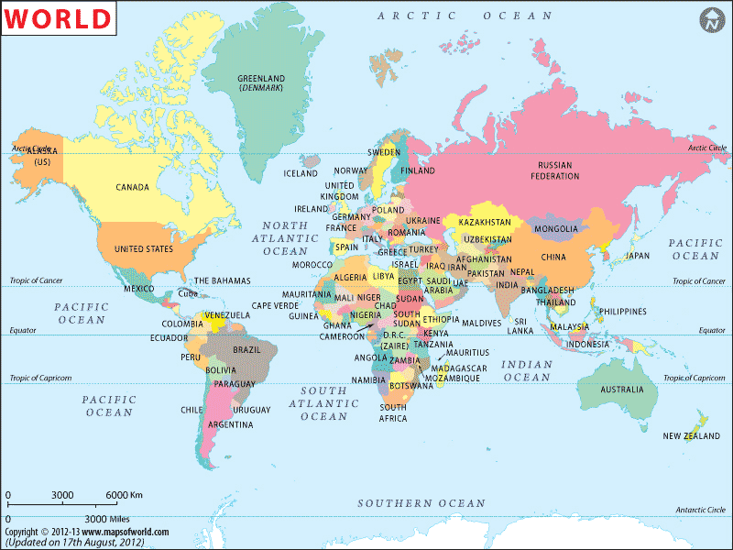
Station 5
Keep in mind Australia, its seasons, rainfall and temperature.
- Which country has the highest temperature? What is it? (Of a single month)
- Which country has the highest rainfall? How much? (Of a single month)
- Looking at Brazil and China Climograph’s.
  - Are they located in the same hemisphere?
  - Explain and justify your answer. (Use examples/data from the graphs)
- Suggest/predict why Singapore does not have a large variation in temperature?
TASK: Answer the following questions using the Climograph below. You will need to INTERPRET and ANALYSE.
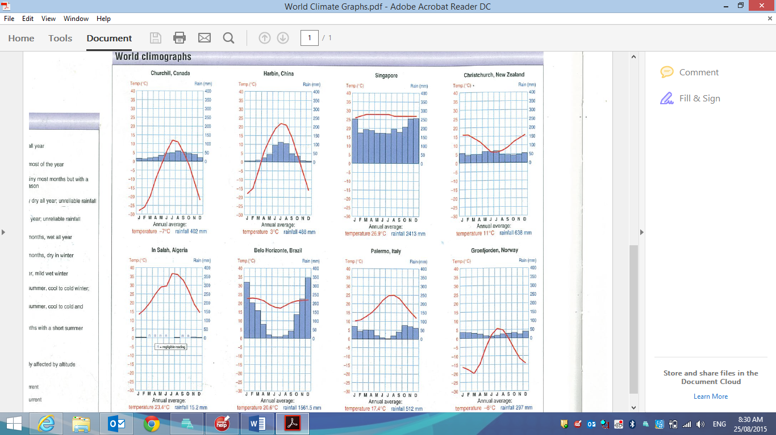
Station 6
Task: You must correctly match the Key Word to its Definition. Read each carefully.
Example Answer: 9 = F, 8 = E
Mix and Match
KEY WORD |  |  |  | DEFINITION
Tropical climate | 1 |  | A | The weather conditions prevailing in an area in general or over a long period that are represented by facts and statistics collected together for reference or analysis.
Average Temperature | 2 |  | B | Also known as ‘Climographs’ these are a combination of a bar graph and a line graph. Temperature is shown on a line graph, with the figures being shown on the right side of the graph. Rainfall is shown by a bar graph, with the figures being shown down the left side of the graph.
Average Rainfall | 3 |  | C | A tropical climate is a climate typically found within the Tropics*, while a few locations outside of the Tropics are considered to have a tropical climate
climate graph | 4 |  | D | the amount of water falling in rain, snow, etc., within a given time and area
climate data | 5 |  | E | The average of the high (max) and low (min) temperature for a given period of time (day, month, year etc).

Station 7
Task: Correctly identify the elements of BOLTSS and BATKIS.
MAPPING |  | GRAPHING
B________ |  | B________
O________ |  | A________
L________ |  | T________
T________ |  | K________
S________ |  | I________
S________ |  | S________

Station 8
Task: Answer the following questions relating to the rainfall map.
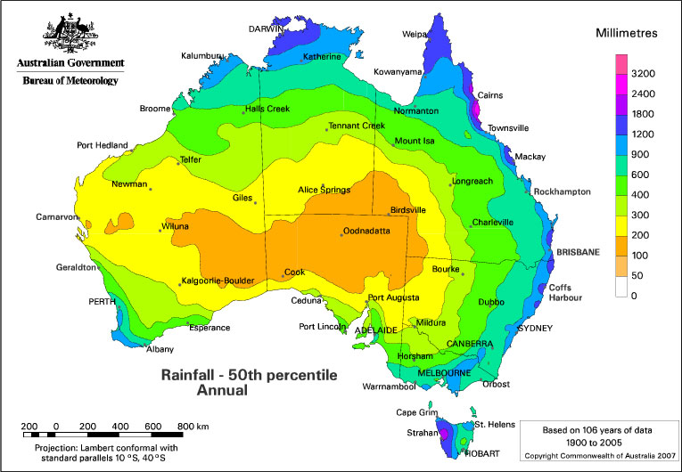
- What do the different colours on the map mean?

- How much rainfall does Brisbane get?

- Name one town which receives between 100-200mm.

- Describe what happens to the rainfall as you move inland from Perth to Cook. (REMEMBER: use specific rainfall amounts and names of towns you come across)

- Predict why there is such as dramatic change rainfall between Perth and Cook.
Station 9
Task: Write a paragraph explaining the Rain Shadow effect. Make sure you refer to the image and use terminology.
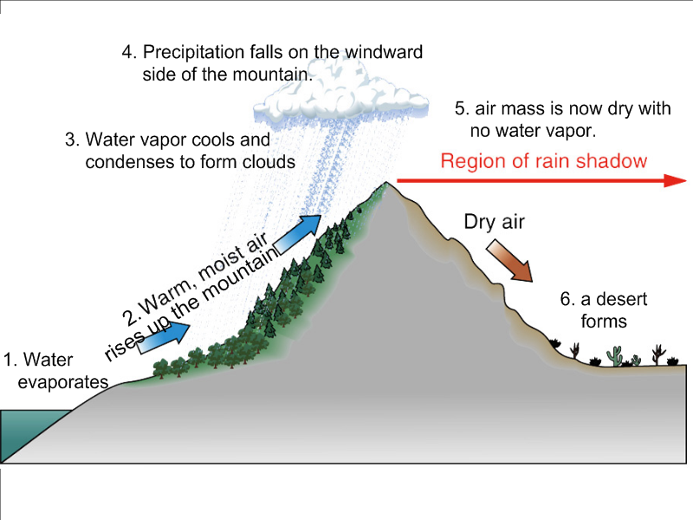
Leeward
Windward
Station 10
Task: Answer the following question about the bird’s eye-view of the rain shadow.
- Looking at the ocean and the mountains, is Gladstone on the windward side of the mountain or the leeward side?

- Create a legend for:
  - Ocean
  - Mountains
  - Light rain
  - Medium
  - Heavy

- Identify the rainfall amount each town receives. (Light, medium, heavy)
- Childers
- Gladstone
- Hervey
Bay
OCEAN

Station 11
Task: Write a PEEEL paragraph about the importance of water in the Hindu culture using the information given.
Water in Hinduism has a special place because it is believed to have spiritually cleansing powers. To Hindus all water is sacred, especially rivers, and there are seven sacred rivers, namely the Ganges, Yamuna, Godavari, Sarasvati, Narmada, Sindhu and Kaveri. Although Hinduism encompasses so many different beliefs among those that most Hindus do share is the importance of striving to attain purity and avoiding pollution. This relates to both physical cleanliness and spiritual well-being.

Pilgrimage is very important to Hindus. Holy places are usually located on the banks of rivers, coasts, seashores and mountains. Sites of convergence, between land and river or two, or even better three, rivers, carry special significance and are specially sacred. Sacred rivers are thought to be a great equalizer. In the Ganges the pure are made even more pure and the impure have their pollution removed if only temporarily. In the sacred water distinctions of caste are supposed to count for nothing, as all sins fall away.

The Ganges river is the most important of the sacred rivers. Its waters are used in puja (worship) and if possible a sip is given to the dying. It is believed that those who bathe in the Ganges and those who leave some part of themselves (hair, bone etc) on the left bank will attain Svarga (the paradise of Indra). The river is said to flow from the toe of Vishnu to be spread into the world through the hair of Shiva.
Funeral grounds are always located near a river. Sometimes at the funeral a small hole is drilled in an earthen pot, which is then filled with water. As the son of the deceased walks around the burning funeral pyre with the pot, dripping water forms a limiting line to prevent the soul from escaping back into the earth as a ghost. On the third day after the cremation the ashes are collected and, on or after the tenth day they are cast into a holy river.

For Hindus, morning cleansing with water is a basic obligation. Tarpana is the point at which the worshipper makes a cup with his hands and pours the water back into the river reciting mantras. Sodhana is Hindu purification and is necessary for different reasons and at different levels. Physical purification is a part of daily ritual which may, in the case of sadhus (Hindu holy people who renounce the world seeking Brahman), be very elaborate. Sodhana is also necessary if caste rules have been broken, for example if someone drinks from the same vessel as a member of a lower caste, and before puja. Every temple has a pond near it and devotees are supposed to take a bath before entering the temple.
The story of the Great Flood of Manu appears in Hindu scriptures. This is the story of how all creation is submerged in a great deluge but Manu is rescued by a fish that he once saved from being eaten by a larger fish. The fish told him to build a large boat and to take into it seeds and animals. The fish then towed the boat to safety by anchoring it on the highest of the Himalayas. He stayed on the mountain (known as Manu's Descent) while the flood swept away all living creatures. Manu alone survived
ihttp://www.africanwater.org/religion.htm
Station 12
Task: Write a PEEEL paragraph about the importance of water in the Hindu culture using the information given.
For Aboriginal people the relationship is much deeper. The land owns Aboriginal people and every aspect of their lives is connected to it.
They have a profound spiritual connection to land. Aboriginal law and spirituality are intertwined with the land, the people and creation, and this forms their culture and sovereignty.
The health of land and water is central to their culture. Land is their mother, is steeped in their culture, but also gives them the responsibility to care for it.
- Aboriginal peoples’ value to water is sacred, deep and necessary for survival. It is protected by Lore, which provide a system of sustainable management ensuring healthy people
- Aboriginal people’s connection with Country does not separate the individual features of the landscape
- Non-Aboriginal laws and traditions separate water from the land and from the sky
- Aboriginal cultural and economic values associated with waters are poorly understood by water resource managers including the cultural economy (i.e. 1 echidna may equal 3 yellow bellies)
- Aboriginal people are critical of water managers for the exclusive focus given to satisfying ecological criteria in environmental watering
Significantly, water isn't just a resource. It is part of culture too. One of the most pervasive figures in Indigenous spiritual life is the Rainbow Serpent, strongly associated with rain and a giver of life. Indigenous cultural interpretations of water help to demonstrate its significance as more than a physical resource.
For Indigenous people, water is an intricate part of the landscape that holds vast social, cultural and economic importance; its value is intangible. It is not easy to marry this with the quantitatively-focused western style of natural resource management which tends to separate components of the landscape into ‘silos
Water is vital to life, essential to agriculture and a valuable energy source which may be utilised in the mitigation of climate change impacts. Water is extremely valuable globally to both Indigenous and non-Indigenous peoples and is used for many different purposes. Water is also important to both for different reasons. For example, non-Indigenous Australians consider water as a spiritual, natural resource and a commodity that is not only essential to livelihood, but has significant economic contemporary value. However, Indigenous groups in many of these ecologically rich and often remote environments Indigenous peoples regard the inland waters, rivers, wetlands, sea, islands, reefs, sandbars and sea grass beds as an inseparable part of their estates. As well as underpinning social and economic well-being, Indigenous people’s relationship with waters, lands and its resources is crucial to cultural vitality and resilience.1 Australia, and in particular the Indigenous estate, includes some of the most biodiverse terrestrial and aquatic environments, including many intact and nationally important wetlands, riparian zones, forests, reefs, rivers and waterways. Australia also has some of the most diverse, unique and spectacular marine life in the world.2 Indigenous rights in water are not adequately recognised by Australian law and policy. This is largely because Indigenous and non-Indigenous perspectives of water and its management differ greatly. This creates difficulties as non-Indigenous laws and management plans separate land from water and generally regard water as a resource available for economic gain. As water is predominantly considered only for its consumptive value, its use and regulation is limited and restricted by governments to industries or individuals willing to pay the highest price. This affects Indigenous access and usage.

